**Research and Initial Ideas for SHOP+**

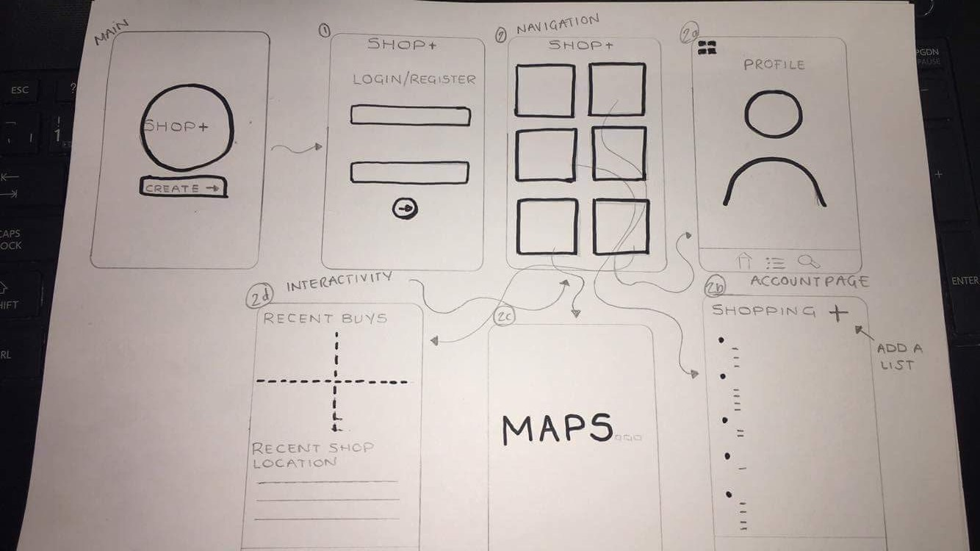**Idea:** An app which allows you to create personal shopping lists with a GPS tracker within the app. A user can create multiple shopping lists that appear on the web page available and you can also monitor where the items are from by keeping them in shop labelled lists. The whole idea behind this app is that a user can create the shopping list on any device they have at home or on the go and then when they walk into the shop specific for a list they have created they get a notification of their shopping list. I thought this would be a good web app for those who want to keep organised. Further thinking to my initial idea, it could link to online shopping and you can find items online and the user would have an option to add them into a shopping list.

**Purpose:** The reasons I thought that this app would be useful is

* The navigation for the web app is simple but efficient. This would increase the amount people that use it because users would find it easy to use compared to other apps already out there.
* A shopping list app would be useful because people are more likely to have their mobiles with them and if they are ones to forget their hand-written shopping lists they’d have it on their phones. It makes a good replacement for hand written lists bringing a shopping list onto technology.
* The shopping list would be easily accessible, meaning it could work at home and you could do your shopping lists from your household and then switch it to a mobile device and all your information still be there. Also, you’d be able to add stuff to your shopping lists on the go.
* During certain time periods if a big shop is needed for Christmas or birthdays this app would be useful because you’d know the specific things you are after and where to get them from.

**Initial technologies:** To build the web application there would be many technologies needed to build it together.

* MongoDB – This would be used to create the databases to hold the data which would include the users; username, password, email address, dates & times and shopping lists.
* Express – To work as a web server
* Angular – Will help build the interface of the web application.
* Google Maps API – With the tracking element of the app this would help the mapping.

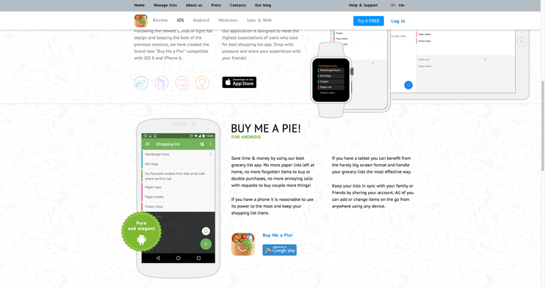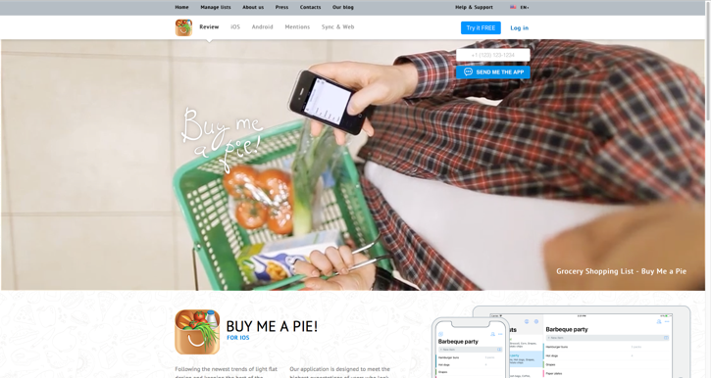**Names:** Shop+, Quick Buy, Go Shop, Shop Flow, Quick List, Quick Buy.

**Research:** Looking into other shopping apps there was a variety but they all do the same thing. However, doing research helped find an app that is similar to the initial idea. This app is <https://buymeapie.com>. This app allows many contributors to make shopping lists and check them off. This app has similar functions and the way a user would navigate.